|  |
| --- |
| CAE simulation 3 |

A gantry crane is designed that must be able to lift 10 tons(use 100KN) as it must lift compressors, motors, heat exchangers, and controls. This load should be placed at the center of one of the main 12-ft-long beams(use 1ft=0.3m) as shown below by the hoisting device location. Weight of the structure is ignored in the analysis. Assume you are using ASTM A36 structural steel(SS400). The crane must be 12 feet long, 8 feet wide, and 15 feet high. The beams should all be the same size, the columns all the same size, and the bracing all the same size. Their cross sections are selected from Appedix F(4th ed.) and shown below. You must verify that the structure is safe by checking the beam's bending strength and allowable deflection. A required safety factor against material yielding of the beam is 3. Verify that the beam deflection is less than L/360 (12/360ft=10mm, downward deflection of the beam center with respect to the ground), where L is the span of the beam. Check yielding and Euler buckling of the long columns. A required factor of safety is 3 against yielding of the column and 5 against buckling of the column.(Ignore local buckling of the horizontal beam) Assume the column-to-beam joints to be rigid while the bracing (a total of eight braces) is pinned to the column and beam at each of the four corners. Use appropriate boundary conditions for the four supports of the gantry crane.

1. Generate an ANSYS beam model and get safety factors and deflections.

**Figure 1.1. Maximum bending stress**

Safety factor = $\frac{245 [MPa]}{81.571 [MPa]}=3.00$

From the material yeild view, safety factor of this structure is $3.00$.

|  |  |
| --- | --- |
| **Total deflection** | **X axis** |
|  |  |
| $$2.5366 [mm]$$ | $$0.6009 [mm]$$ |
| **Y axis** | **Z axis** |
|  |  |
| $$2.0337 [mm]$$ | $$2.6633 [mm]$$ |

* **Deflection**

2. Compare simulation results with appropriate theoretical results (stresses and downward deflections of the horizontal beam, critical buckling load of the columns).

2.1. Maximum bending stress

To calculate maximum bending stress in the structure, second moment of inertia of I beam has to be calculated. And that value can be calculated as follows :

$$I_{I-beam}=2.5073×{10}^{-4} [m^{4}]$$

Both max moment on the horizontal beam and following maximum bending stress can be calculated as follows :

$$M_{max}=\frac{PL}{4}=9.00×{10}^{4} [Nm]$$

$$σ_{max}=\frac{Mc}{I}=\frac{9.00×{10}^{4}×\frac{(454.66×{10}^{-3})}{2} }{2.5073×{10}^{-4}}=81.60 [MPa]$$

2.2. Downward deflection

To calculate the downward deflection of horizontal beam, deflection of rect tube structure due to axial force and the deflection of I beam structure due to axial force has to be considered simultaneously. Those two cases in this structure can be calculated sequencially as follows :

$$I beam : δ_{I_beam}=\frac{P∙L^{3}}{48EI}=\frac{100[kN]×{\left(12×0.3\right)}^{3}}{48×200[GPa]×2.5073×{10}^{-4} [m^{4}]}=0.0019 [m]$$

$$rect beam \left(vertical beam\right) : δ_{rect_beam}=\frac{\frac{P}{2}×L}{EA}=\frac{50[kN]×(15×0.3)[m]}{200\left[GPa\right]×0.0014[m^{2}]}=0.783×{10}^{-4} [m]$$

$$deflection= δ_{I_{beam}}+δ_{rect_{beam}}=0.0027 \left[m\right]=2.7 [mm]$$

2.3. buckling

Except local buckling occurs in the I beam (horizontal), only buckling in the vertical rect tube beam has to be considered.

$$P_{cr}=\frac{n π^{2}EI}{L^{2}}=2.4925×{10}^{5} [N]$$

$$n=0.25 \left(fixed-free boundary condition\right)$$

$$E=200 [GPa]$$

$$I=1.0228×{10}^{-5} [m^{4}]$$

In the mode 3, vertical beam buckling occurs and the load multiplire is $6.0806$.

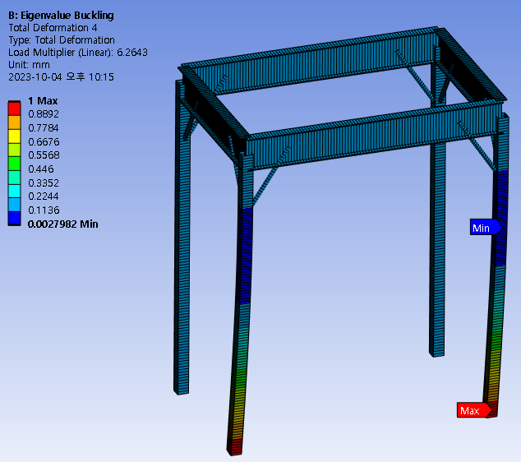

**Figure 2.1. Vertical beam buckling**

So, the critical load at that case can be calculated as follows :

3. Discuss on boundary conditions of the four supports.

As mentioned in the **2.3. buckling**, n value used for calculating critical load has to be adjusted differently according to the boundary conditions. N values used for calculating critical load in four boundary conditions are defined as follows :

$$P_{cr}=\frac{n π^{2}EI}{L^{2}}$$

$$n=1 (pin to pin)$$

$$n=0.25 (fix to free)$$

$$n=4 (fix to fix)$$

$$n=2.046 (fix to pin)$$

In this case, fix to free boundary condition for vertical beam has to be adjusted.

4. What do you think the function of the braces are?

- Enhancement of Structural Strength : Circular hollow section braces typically enhance the strength of structures and improve their stability. These components are usually made of steel or metal and serve to distribute stress between structural members, enhancing a structure's resistance to external loads such as wind or seismic forces.

- Resistance to Seismic and Wind Loads : Especially in structures designed to withstand lateral loads like earthquakes or wind, circular hollow section braces play a crucial role. These braces absorb and distribute stress generated by earthquakes or wind, limiting deformations in the structure.

- Support in Buildings or Bridges : Circular hollow section braces are often used as key components providing support and strength in buildings, bridges, towers, and other structures. They are commonly employed in the external bracing of tall buildings and in large-span bridges.

|  |  |
| --- | --- |
| **Mesh size : $315 \left[mm\right]$** | **Mesh size : $200 [mm]$** |
|  |  |
| # of elements : $132$ | # of elements : $200$ |
| **Mesh size : $60 [mm]$** | **Mesh size : $40 [mm]$** |
|  |  |
| # of elements : $652$ | # of elements : |

5. How many number of elements is required to accurately solve this problem?

As can be seen in the figure above, setting the mesh with default size can be accurately solved.